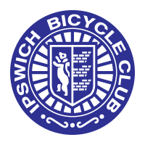

IPSWICH BICYCLE CLUB

<https://ipswichbicycleclub.co.uk/>

Open 10 Mile Time Trial

Promoted for and on behalf of Cycle Time Trials under their Rules & Regulations on

Saturday 8th June (14:00)

Henley Circuit

Officials

Time keeping: Mr Angus Jardine and Mr Mark Salter

Thanks to Marshals: Clive Tricker, Tracey McKenzie, Sean Marner, Laura Davies, Paul Rippon.

Thanks to Anne Betts for the Lovely Teas

Event Secretary: Jon Carlyon

123 Parliament Rd, IPSWICH, Suffolk, IP45EP

[carljonath@aol.com](mailto:carljonath@aol.com) 07910 802047

Prizes were given one per rider, excluding team, to the highest domination won.

Scratch

1st Matt O'Brian £30

2nd Matt Peck £20

3rd Joe Shaw £10

Fastest Lady: Becky Ridge £30

Vet on Standard

1st Ian Short £30

2nd David Ackerley £20

3rd Geoff Wharton £10

Team: Loose Cannon’s conditioning: Matt O’Brian, Becky Ridge, Thomas Hudson (£10 per rider).